Case 19-AM,C-Taino-Itiba Cahubaba- Great Bleeding Mother-Marble

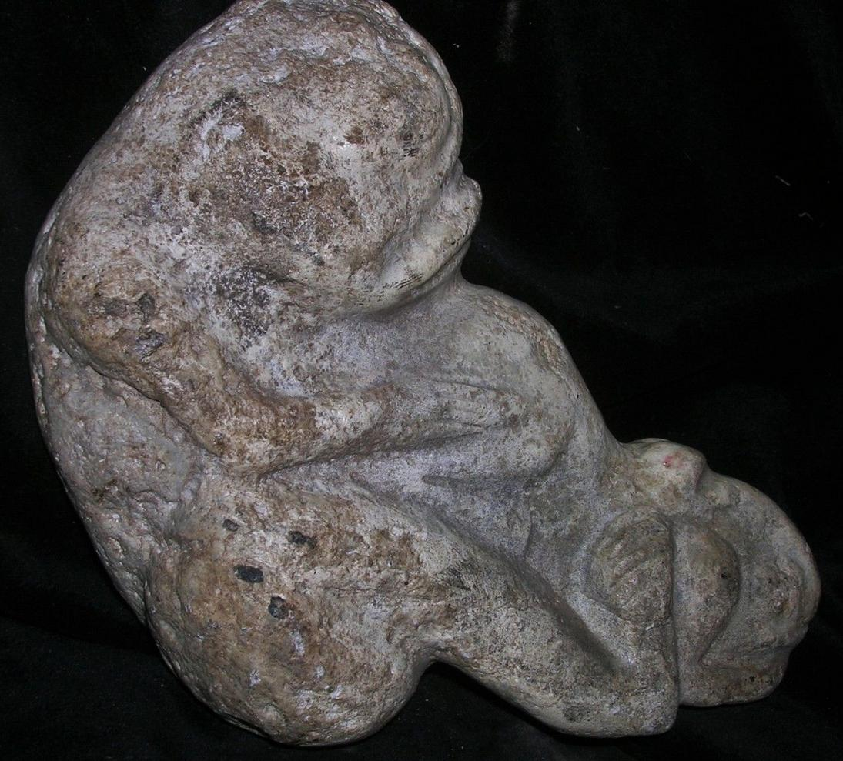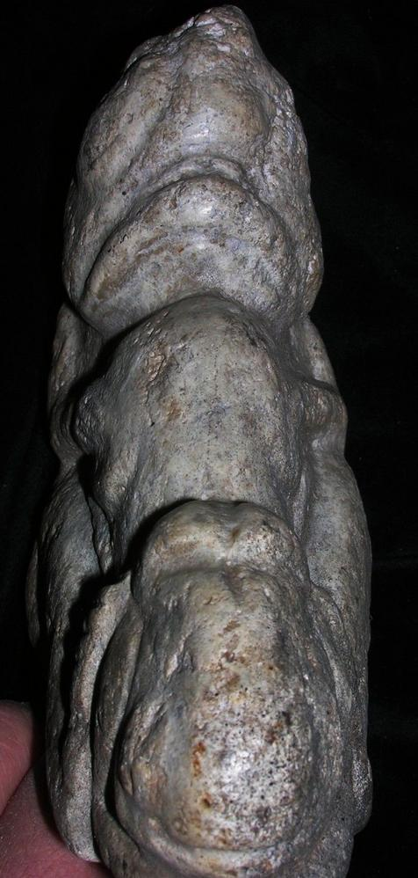
Case No.:
Accession Number:
Formal Label: AM,C-Taino-Itiba Cahubaba- Great Bleeding Mother-Marble
Display Description:
Itiba Cahubaba, “Great Bleeding Mother,” is a primary ancestor spirit among Taino deities called cemís (zemís). Itiba Cahubaba dies in childbirth, begetting quadruplets as depicted with two of the four held in each hand in the figure above. The quadruplets were symbols of the four cardinal points and the four elements: fire, water, air and earth involved in the myth of Yaya and his son Yayael that gave rise to the human species.
Identified by Caribbean scholar José Juan Arrom, Itiba Cahubaba is notable for her eyes, indicative of Taíno depictions of deities. Itiba’s emaciated arms, always folded over her bulging belly, represent the suffering of her creation. Cosmic navigator, Itiba Cahubaba wears a headdress with four trapezoid incisions that appear to depict the Caribbean winter (short) and summer (long) solstices.
the first woman to give birth and the ancestress of all humanity,
Recorded in a Taíno myth recorded ca. 1496 by Catalan Spanish Jeronymite Priest Ramón Pané (chapters IX-X),
First.
This sculpture provides visual representation of the anguish of Itiba Cahubaba in the last stages of pregnancy prior to her fate of dying in childbirth. Her mouth is in a grimace, and her spine is showing through her skin suggesting emaciation.

Second.
This sculpture provides visual representation of the placement of a surgical incision drawn 3-4 inches above her navel prior to the caesarean section that successfully resulted in the delivery of her quadruplets, four male children.

Third.
This sculpture invokes the Tainó world-view as a mixture of black as well as white, capacious enough to hold opposites in tension. Therefore, Tainós invoked opposites as dualities not as dichotomies in their world-view.
They could interpret the number “four” as fertility and as the inverse of fertility. Indeed, Itiba Cahubaba had to die to bring forth life.

LC Classification:
Date or Time Horizon:
Geographical Area:
Map:
GPS Coordinates:
Cultural Affiliation:
Medium:
Dimensions:
Weight:
Provenance: John Therien Estate, NYC, 6/25/68 Collected
Condition:
Discussion:
In another myth Yayael, the son of Yaya, a mythical cacique, was banished from his home island. He was commanded to seek a new home elsewhere. However, he broke this commandment and returned after 4 months only to be ritually executed by his father for not heeding his father’s sentence of total banishment. Among island people the carrying capacity of the island was of paramount importance to a cacique and the people over whom he was designated to protect, and banishment was one way to address the problem of over-fertility that could outstrip an island’s necessarily limited natural resources and put everyone at risk.
In Cuba, Itiba Cahubaba is associated with pregnancy, labor, delivery, and—among the people of the eastern mountains—the Virgen de la Caridad del Cobre, the matron saint of the island. Many pregnant and post-natal women attend the Virgen’s shrine in supplication and thanks. Taíno descendants from the Sagua–Baracoa Mountains still make offerings and burn tobacco for the Mother Earth spirit and attribute the success of their crops and the potency of their traditional herbal medicines to her benevolence.¹ The names of Caribbean Taíno cosmological personalities also continue to figure in the toponymy of the islands. There is a historic Río Cahobabo and a nearby village Playitas de Cahobabo in the easternmost part of Cuba. The local population from the region of Cahobabo sustains many Native herbal and culinary traditions.

Sold by primitifstuffgal... ( 2214 )

Delivery package 1 of 1
Estimated delivery Tuesday, Mar 29, 2016 - Friday, Apr 1, 2016
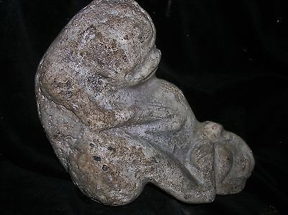

ORIG $399. PRE COLUMBIAN TAINO FIGURE 7➕" PROVENANCE
Item price | $99.99
Quantity | 1
Item number | 222058876885
Shipping service | USPS Priority Mail

Shipping address
Ralph J Coffman Jr149 Atlantic AveSwampscott MA 01907-2427United StatesOrder total
Subtotal | $99.99
Shipping | $10.92
Total$110.91
Order placed onTuesday, Mar 22, 2016 Payment methodPayPal Payment dateTuesday, Mar 22, 2016

